Okmulgee Creek and the water that flows into it.
www.bluethumbok.com November, 2023

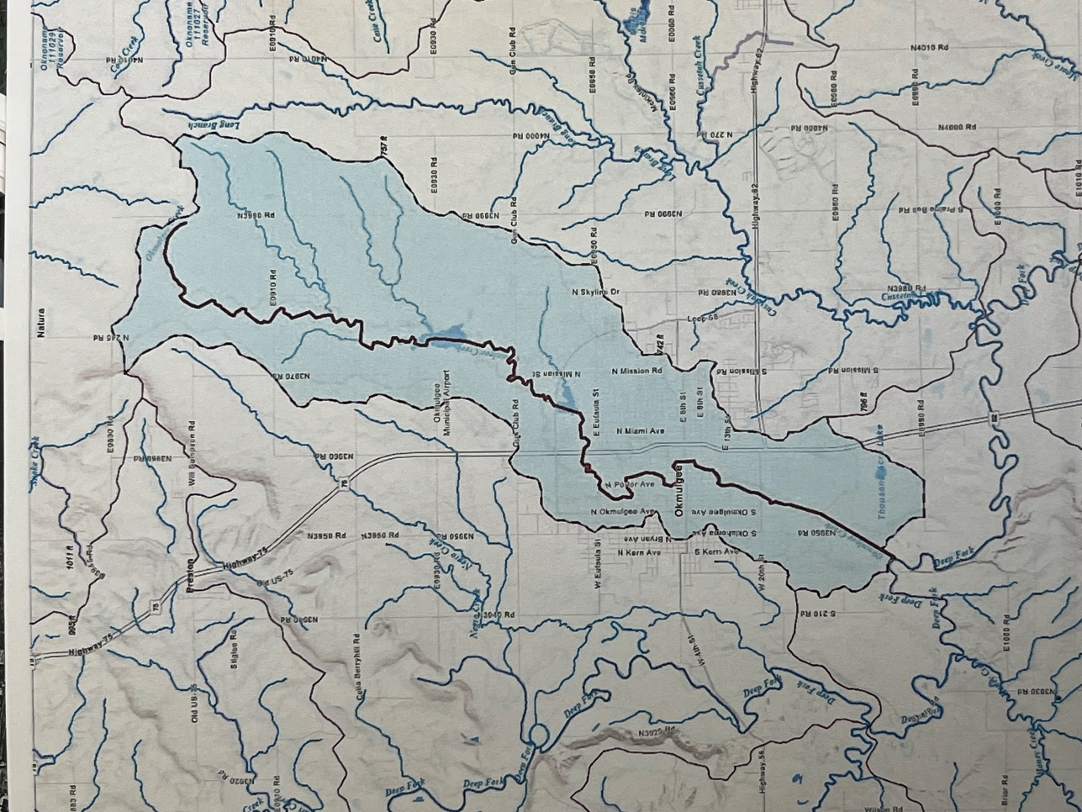

Left Photo: Volunteer Monitors Maggie and Maddie Amador. Okmulgee Creek & 13th Street.
Right Photo: Watershed of Okmulgee Creek, NWNWSE7-13N-13E, 35.6154, -95.9693
Waterbody ID #: 05520700-01-0290L (Okmulgee County, Oklahoma)
STORMWATER RUNOFF:
- Impervious surfaces such as rooftops, driveways, parking lots, and roads, prevent water from being absorbed into the ground.
- The portion of water that is not absorbed into the ground becomes “stormwater runoff.”
- This water picks up and carries pollutants and debris- such as soil, fertilizers, pesticides, pet waste, trash, and motor oil. These things, and many more things, are defined as “nonpoint source pollution.”
- Okmulgee Creek can be impacted by polluted runoff.
- Stormwater is not filtered nor is it treated at a wastewater treatment plant.

HOW YOU CAN HELP:
- Keep storm drains free of litter and debris.
- Do not rake, blow, or dump grass clippings into storm drains.
- If using fertilizers or pesticides, follow label instructions to minimize chemicals entering the stormwater system. Additional – have soil tested to see if fertilizer is needed, never apply lawn chemicals if rain is predicted.
- Consider using native plants – these plants are happy with local pests and the existing soil nutrients. Their deep root systems encourage infiltration. Native plants also create food and habitat for birds and pollinators.
- Reduce bacteria by cleaning up after your pet, both in your yard and when you are out for a walk.
- Never dump used motor oil, paint, chemicals, or other substances into a storm drain. Storm drains are for rain only!
- Keep vehicles well-maintained so that they do not leak oil, brake fluid, etc.

FISH COLLECTION FROM OKMULGEE CREEK SUMMER 2021:
- Streams will be homes for fish unless something stops the fish from living there.
- In the fish collection of 2021, a total of 412 fish were collected.
- 15 species were represented.
- All species fall in the tolerant and intermediate categories
- No species that are intolerant to pollution were collected.

Fifteen species of fish is a reasonable number, but because of the condition of the water there are no fish that are intolerant to pollution living in the creek. Okmulgee Creek is in the Central Irregular Plains Ecoregion, and a high quality reference stream in this ecoregion is expected to have five species that are intolerant to pollution.

MACROINVERTEBRATES COLLECTION FROM OKMULGEE CREEK WINTER 2022:
- Stream life tends to refer to either fish or benthic macroinvertebrates. These are usually small larval aquatic insects that make up fish food.
- 101 total macros counted*
- 15 different species
- The macros that can live in water with high levels of pollution are called ”pollution tolerant.”
- There are no sensitive macros living in the creek because the condition of the water will not support them.
Overall the condition of the creek is fair to good for macros. Three winter collections and two summer collections for benthic macroinvertebrates indicate fair to good water quality, although no macros that are intolerant to pollution appeared in any of the samples.
*macros refers to benthic macroinvertebrates, often the aquatic larval insects in a stream. The subsampling process removes a statistically relevant portion of macroinvertebrates from a preserved sample so that the subsample can be used to evaluate the quality of life in the stream.

WATER CHEMISTRY:
Oxygen levels fall in the good range with a dissolved oxygen saturation of 80%-100%. The pH of the water is consistent when we test with the pH result nearly always 7.5.
The phosphorous level says there is a problem. Low to mid-range readings are consistent. It possibly could be from bank erosion, lawn chemicals or any number of things. This is of concern and warrants continued monitoring.
Blue Thumb monitoring is very basic, and there are a number of pollutants that are not tested for in the basic monthly monitoring.

OKMULGEE CREEK SUMMARY
Okmulgee Creek is a stream that is barely holding its own in a mixed landuse watershed, much of which is urban. Both the fish and the benthic macroinvertebrates show a stream that has no sensitive species, unlike the reference streams to which it is compared. Continued monitoring will keep track of degradation or improvements. It is likely that with education in the watershed the stream can be brought to a better condition.
Okmulgee Creek is a tributary of the Deep Fork River which flows through the Deep Fork National Wildlife Refuge. Research into the history of Okmulgee Creek revealed that there has been at least one fish kill that also impacted the Deep Fork River. This kill was a point source pollution problem, and the monitoring site at 13th Street was not affected by this fish kill.
Blue Thumb is a water quality education program that supports volunteers who monitor streams and educate the public about stream, river, and lake protection. For more information contact Blue Thumb Volunteer Coordinator Cheryl Cheadle, 918-398-1804, or cheryl.cheadle@conservation.ok.gov.

